Spatiotemporal Dynamics of Mangrove Forest Canopy Density: A Multi-Decadal Assessment (1989–2020) in the Sundarbans Reserved Forest, Bangladesh

1. Project Importance and Ecological Significance
The Sundarbans mangrove ecosystem represents the world’s largest contiguous mangrove wetland and serves as a vital natural shield against tropical cyclones, tidal surges, and coastal erosion along the northern Bay of Bengal coastline. Beyond coastal protection, this UNESCO World Heritage Site functions as a major global carbon sink and supports high biological diversity. However, escalating climatic stressors, shifting salinity gradients, recurrent extreme storm disturbances, and regional anthropogenic pressures have induced continuous structural modifications within the mangrove canopy.
Monitoring forest canopy density (FCD) is essential for evaluating forest structural health, tracking degradation or regeneration trajectories, and quantifying localized biophysical responses over multi-decadal timelines. Utilizing advanced optical remote sensing indices provides an empirical basis for assessing biophysical shifts without extensive, destructive field sampling. This study applies biophysical indices—including the Advanced Vegetation Index (AVI), Bare Soil Index (BSI), Canopy Shadow Index (CSI), Vegetation Density (VD), Scaled Vegetation Density (SVD), and Scaled Shadow Index (SSI)—to model canopy density shifts across a critical coastal segment of the Bangladesh Sundarbans over a 31-year period (1989, 2000, 2010, and 2020).

2. Study Area Profile
The study area is located within the Sundarbans mangrove tract in southwestern coastal Bangladesh, bounded approximately between latitudes 22°00′00″ N and 22°30′00″ N and longitudes 89°24′00″ E and 89°42′00″ E.
This dynamic deltaic environment is characterized by an intricate network of tidal rivers, channels, and muddy intertidal flats. The vegetation is dominated by halophytic mangrove assemblages, primarily Heritiera fomes (Sundari) and Excoecaria agallocha (Gewa), interspersed with Sonneratia apetala (Keora) and Avicennia species along tidal fringes. The northern portion transitions toward interior brackish zones, while the narrow southern extension tapers into direct marine contact along the coastal fringe, making the canopy sensitive to tidal inundation, sediment deposition, and storm-driven disturbances.
3. Biophysical Index Modeling and Parameter Distribution
The Forest Canopy Density (FCD) model integrates several biophysical indices to synthesize vegetation greenness, bare soil exposure, and crown shadowing dynamics into a comprehensive canopy cover layer.
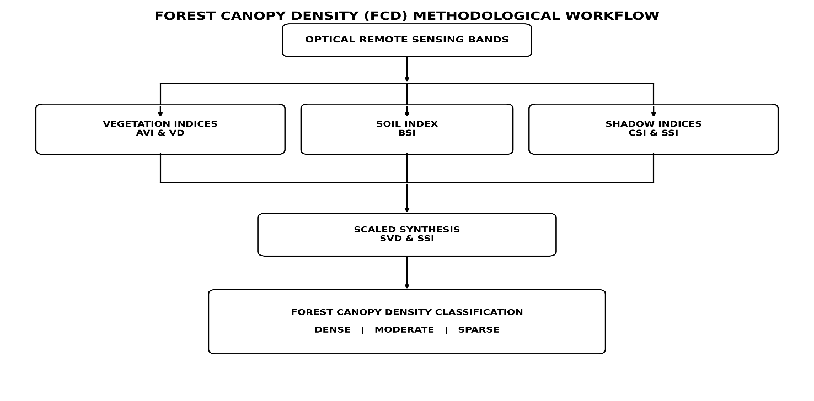
Figure 1: FCD Workflow
3.1 Spatial Distribution of Biophysical Indices in 1989
In 1989, baseline vegetation conditions reflected stable mangrove canopy coverage. The Advanced Vegetation Index (AVI) ranged from 0 to 4.61, indicating robust chlorophyll reflectance across the core forest interior. Vegetation Density (VD) values spanned between 93.19 and 106.11, while Bare Soil Index (BSI) values remained confined between 93.19 and 103.16, with exposed substrate visible primarily along natural tidal mudflats and shoreline margins. Scaled Shadow Index (SSI) values ranged from 0.03 to 99.10, capturing crown stratification across mature forest stands.
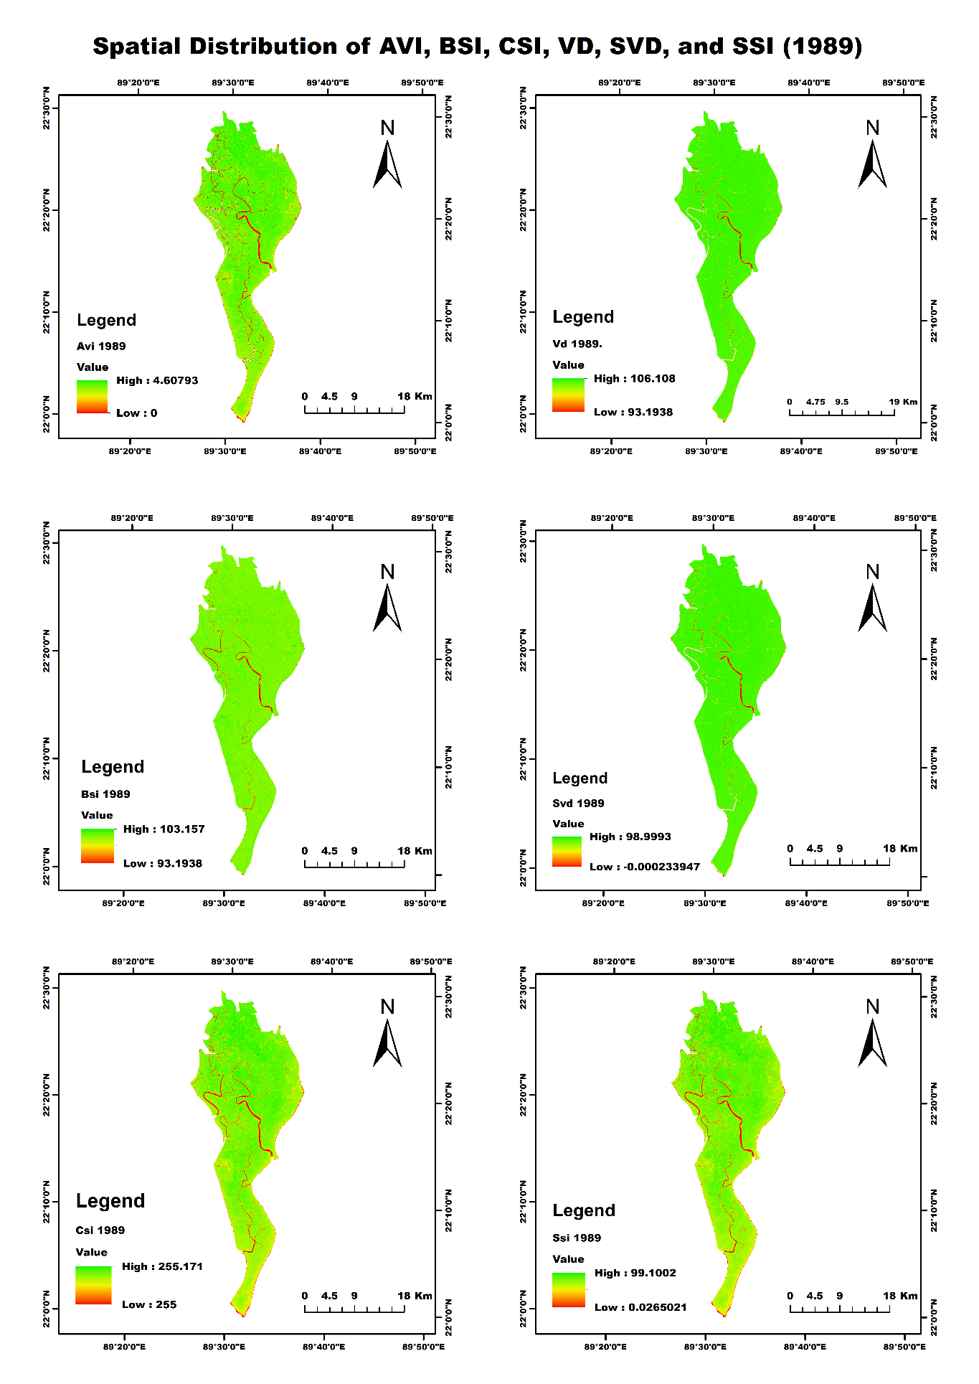
Figure 2: Spatial distribution of AVI, BSI, CSI, VD, SVD, and SSI across the study area for the baseline year 1989.
3.2 Spatial Distribution of Biophysical Indices in 2000
By the year 2000, biophysical parameters exhibited subtle transitions in crown texture and vegetative density. AVI values reached a peak of 4.75, showing sustained high vegetative vigor in core undisturbed zones. The Vegetation Density (VD) surface spanned from 92.10 to 106.19, and Scaled Vegetation Density (SVD) reached up to 98.10. Bare Soil Index (BSI) values remained localized (92.01 to 102.58), demonstrating stable vegetative cover along central river channels despite localized thinning on interior forest edges.
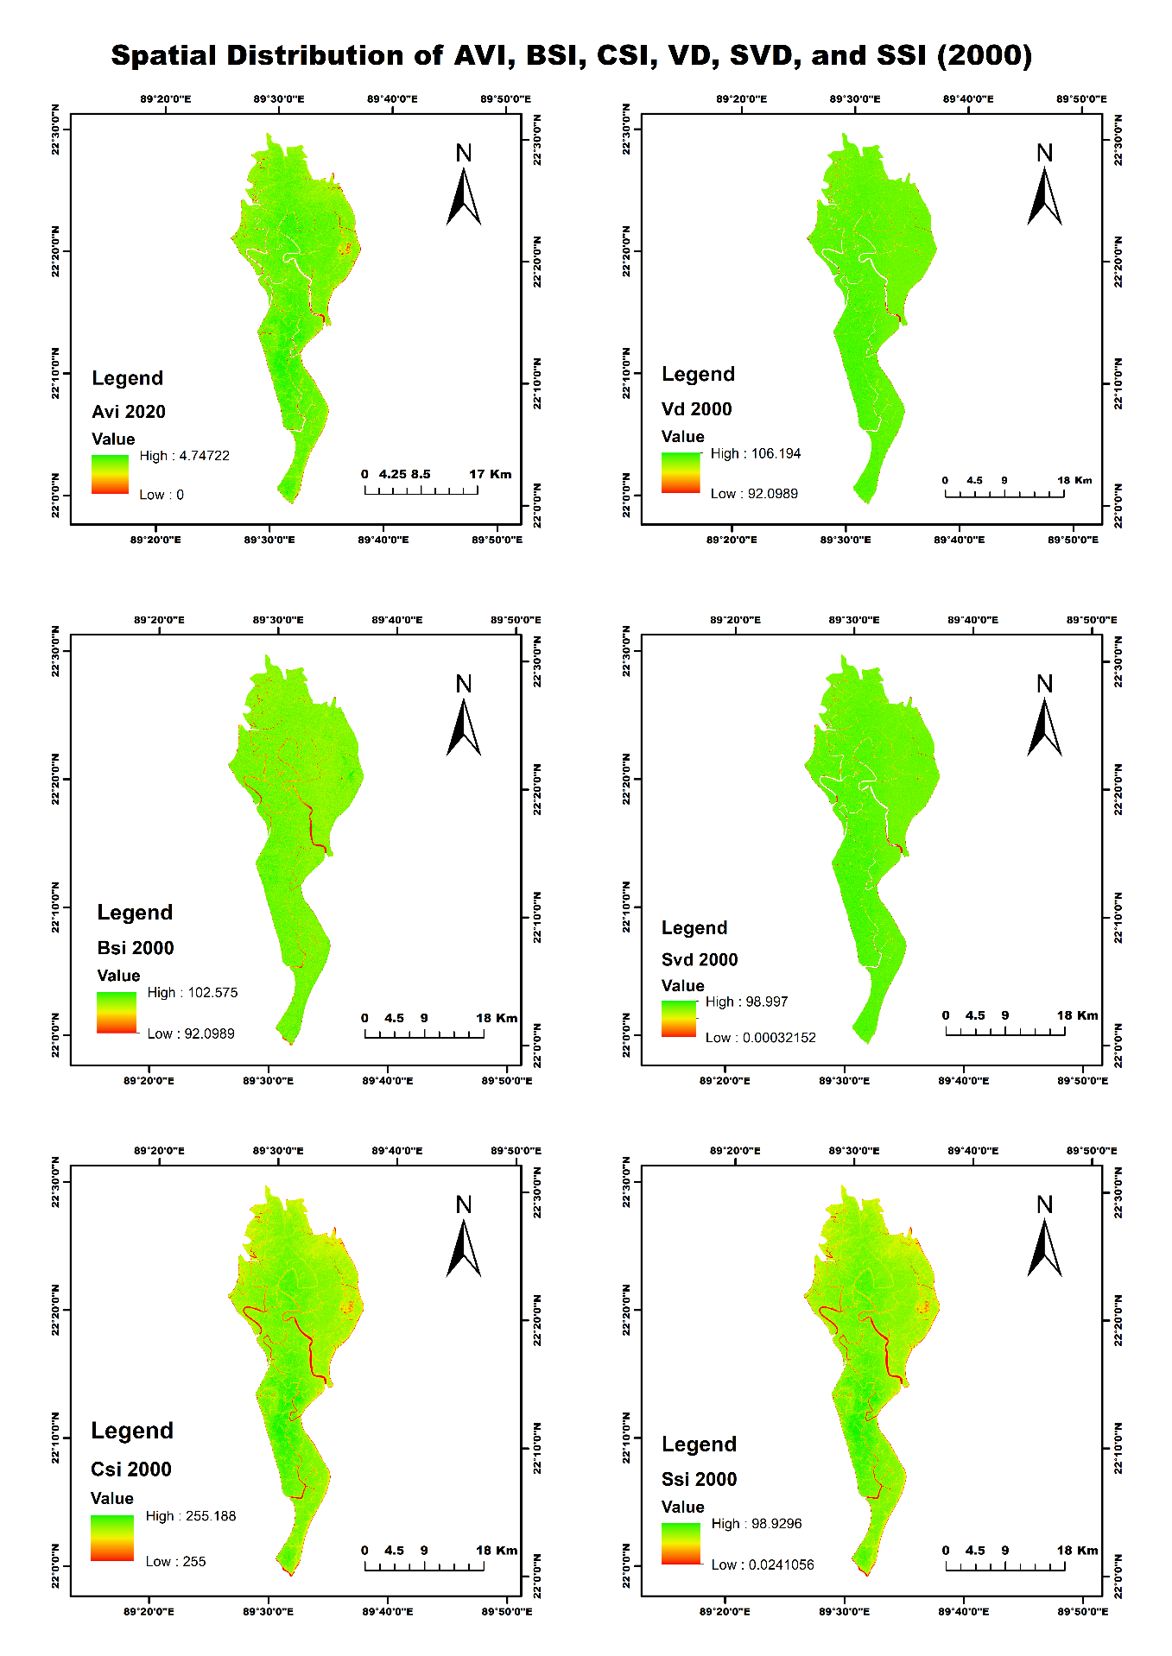
Figure 3:Spatial distribution of AVI, BSI, CSI, VD, SVD, and SSI across the study area for the year 2000.
3.3 Spatial Distribution of Biophysical Indices in 2010
The 2010 index maps display significant structural disruption within the northern and central interior forest blocks. AVI values showed localized contractions (ranging from 0.20 to 4.28), while the Bare Soil Index (BSI) dropped to a lower minimum baseline of 60.34 and recorded high localized values up to 96.59 in the north. Vegetation Density (VD) contracted to a minimum of 64.51 with a high of 101.67, driven by widespread canopy defoliation following severe historical cyclone disturbances, including Super Cyclone Sidr in late 2007. The Scaled Shadow Index (SSI) reflected this disturbance, registering negative lower bounds (-0.72 to 98.42).
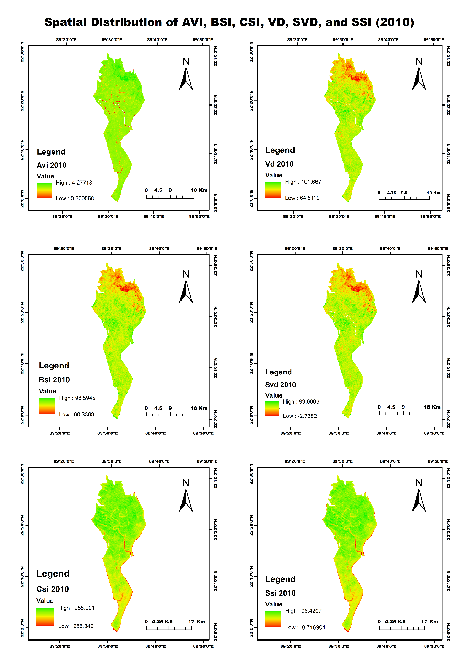
Figure 4: Spatial distribution of AVI, BSI, CSI, VD, SVD, and SSI across the study area for the year 2010.
3.4 Spatial Distribution of Biophysical Indices in 2020
The 2020 parameter distribution highlights substantial canopy regeneration across previously defoliated compartments. AVI dynamic range expanded significantly up to 32.06, reflecting dense foliage biomass and vigorous secondary regrowth. Vegetation Density (VD) stabilized at high thresholds ranging from 94.49 to 131.53, while Scaled Vegetation Density (SVD) reached 99.00. High Canopy Shadow Index (CSI) and Scaled Shadow Index (SSI) values (up to 98.90) confirmed the re-establishment of a multi-tiered, closed mangrove crown canopy across the landscape.
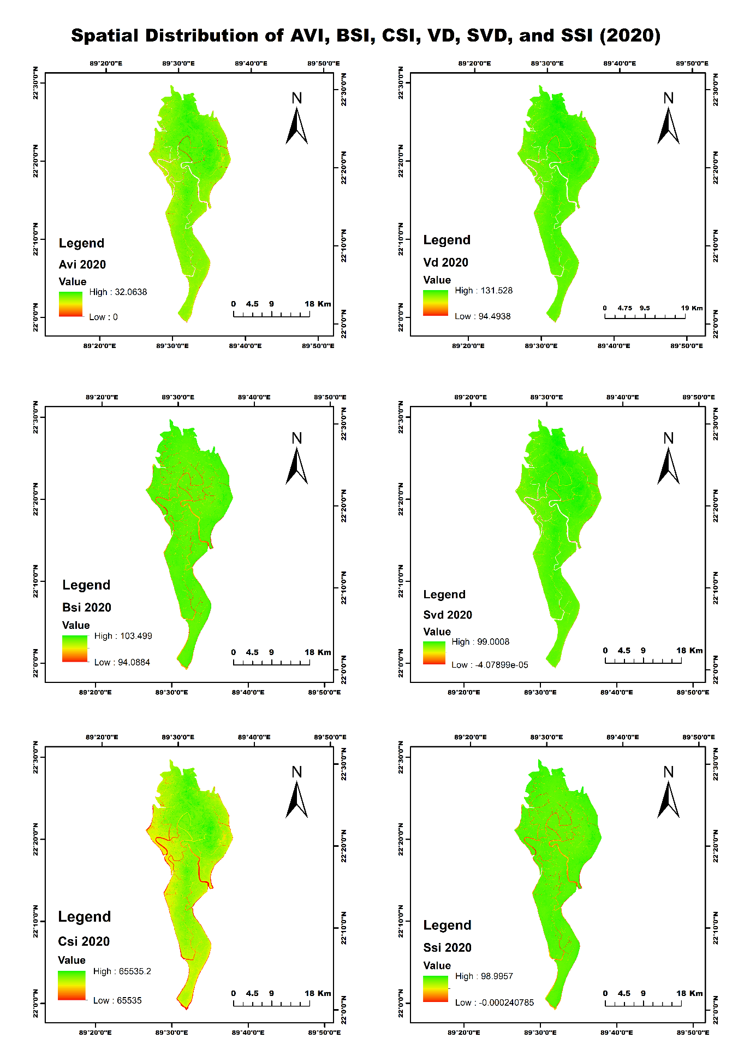
Figure 5: Spatial distribution of AVI, BSI, CSI, VD, SVD, and SSI across the study area for the year 2020.
4. Decadal Spatiotemporal Forest Canopy Density Classification
The integrated Forest Canopy Density (FCD) surfaces were classified into three primary structural categories: Dense Canopy (Dark Green), Moderate Canopy (Light Green), and Sparse Canopy (Orange/Red).
4.1 Forest Canopy Density Status in 1989
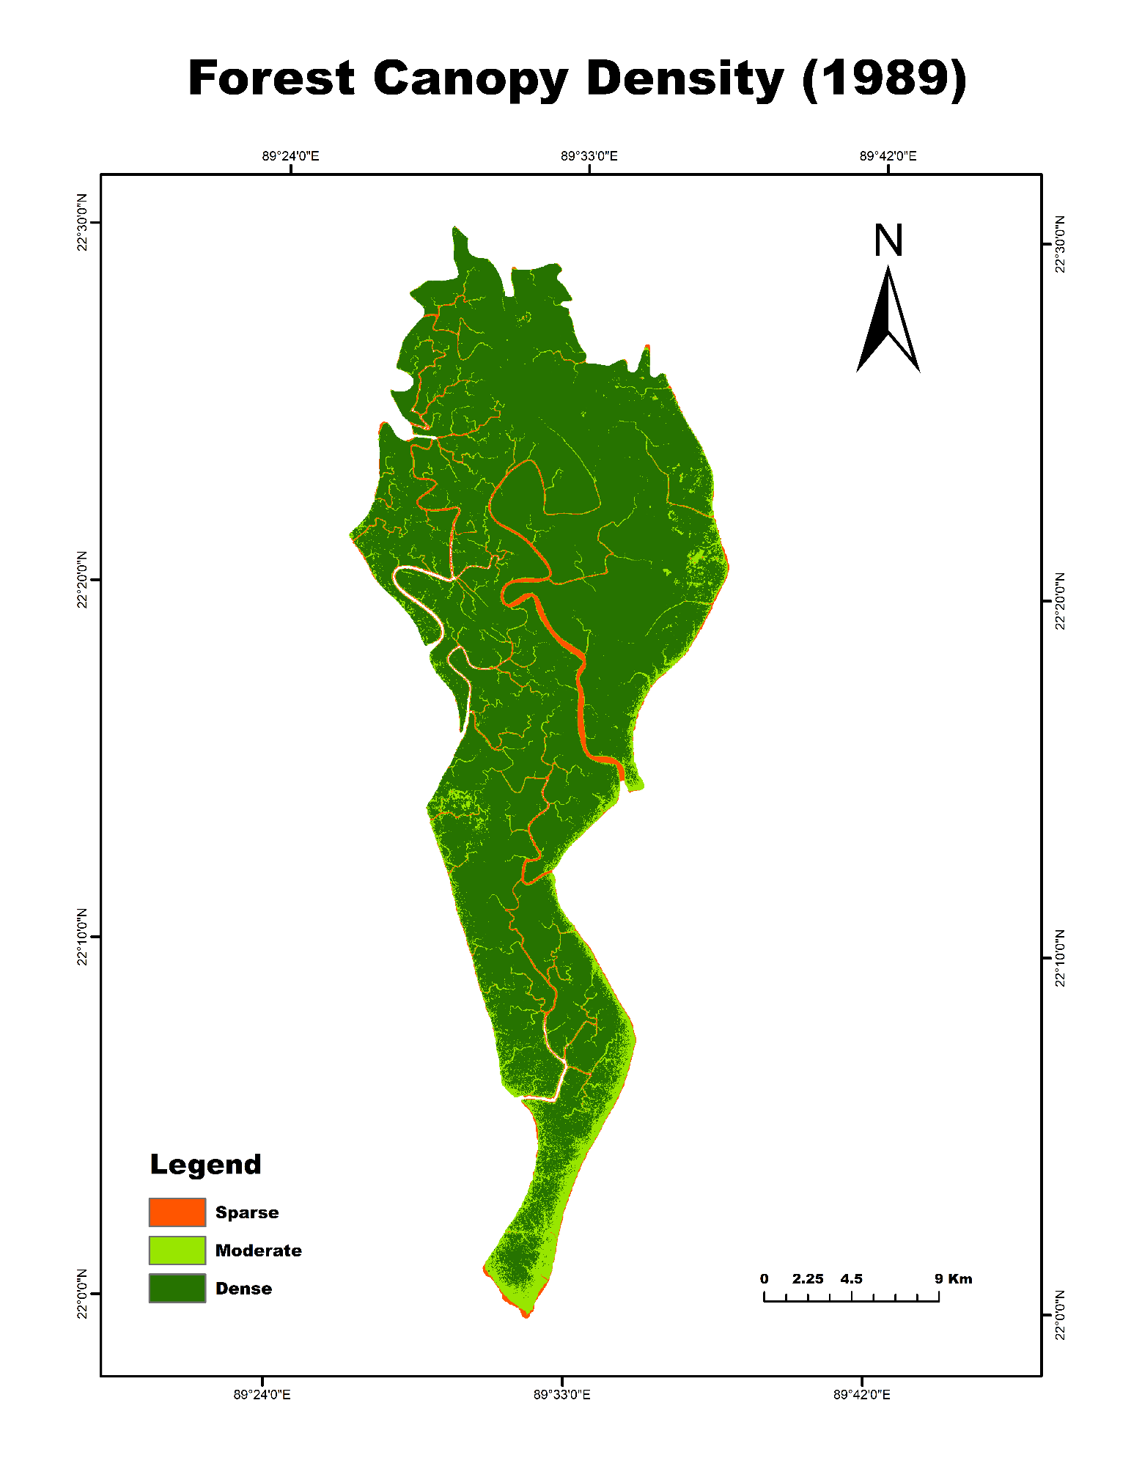
Figure 6: Classified Forest Canopy Density map of the study area in 1989.
In 1989, the study area exhibited high ecological integrity dominated by Dense Canopy cover throughout the northern, central, and interior zones. Moderate canopy stands were restricted primarily to peripheral coastal fringes and along immediate riverbanks where tidal flushing is highest. Sparse canopy cover was minimal, confined strictly to dynamic river channel networks, mudflats, and natural shoreline accretion zones.
4.2 Forest Canopy Density Status in 2000
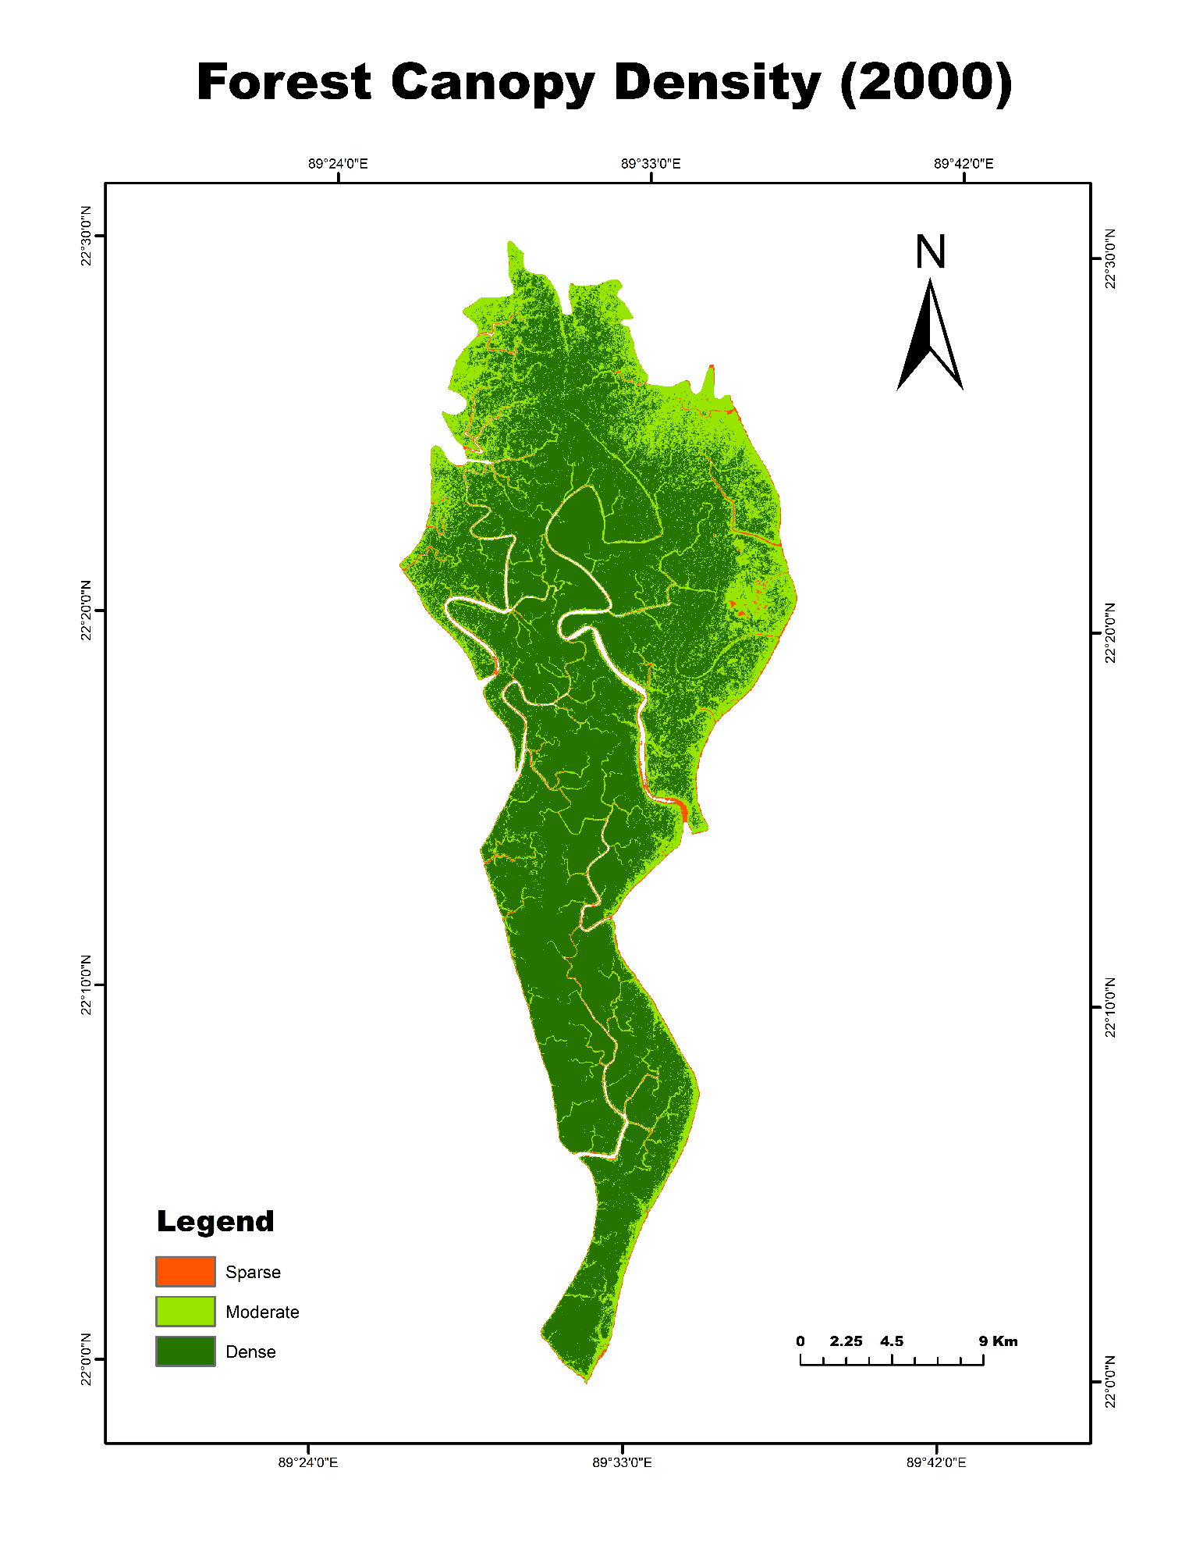
Figure 7: Classified Forest Canopy Density map of the study area in 2000.
By 2000, initial signs of canopy thinning appeared in the north-central and peripheral zones. While the southern elongation retained continuous Dense Canopy stands, noticeable patches of the northern interior shifted from Dense to Moderate Canopy. This shift reflects localized canopy thinning, changing hydro-salinity regimes, and small-scale natural stand mortality, although overall sparse canopy levels remained low.
4.3 Forest Canopy Density Status in 2010
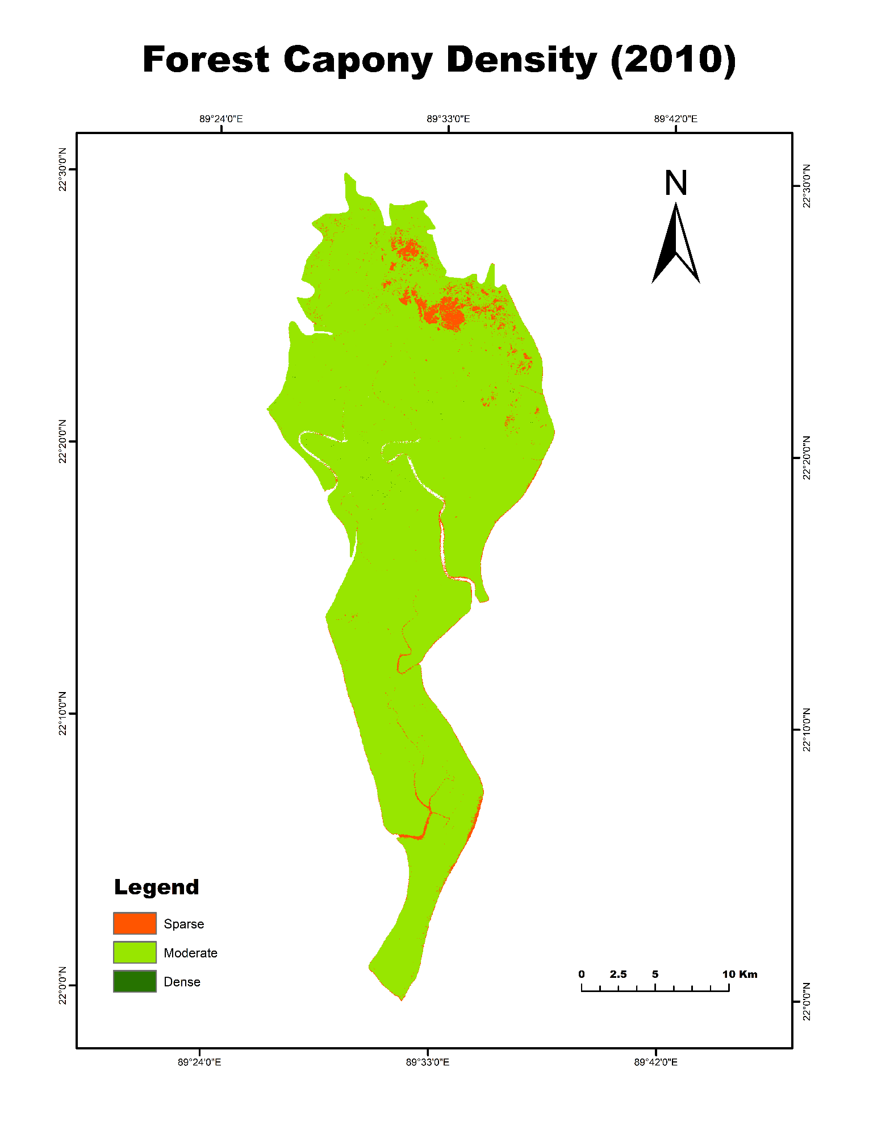
Figure 8: Classified Forest Canopy Density map of the study area in 2010.
The 2010 canopy classification reveals a severe, landscape-level structural collapse. Driven by catastrophic cyclonic wind-throws and storm surges—most notably from Cyclone Sidr (2007) and Cyclone Aila (2009)—the majority of the previously dense mangrove forest degraded into Moderate Canopy cover. Furthermore, extensive clusters of Sparse Canopy (highlighted in bright orange) emerged across the northern and northeastern interior blocks, indicating widespread tree uprooting, crown breakage, and severe defoliation.
4.4 Forest Canopy Density Status in 2020
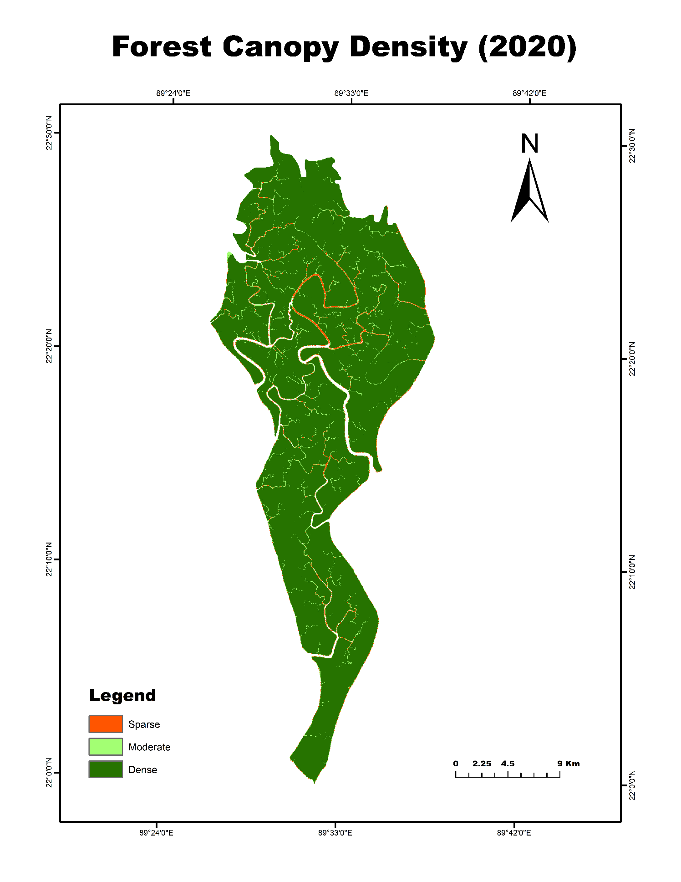
Figure 9: Classified Forest Canopy Density map of the study area in 2020.
The 2020 map demonstrates remarkable natural forest resilience and canopy regeneration over the subsequent decade. The widespread sparse patches observed in 2010 were almost entirely re-vegetated, and the dominant landscape matrix returned to a continuous Dense Canopy classification. This complete recovery across both northern blocks and the southern coastal tongue underscores the high regenerative capacity of mangrove ecosystems when protected from direct anthropogenic encroachment.
5. Summary Matrix of Canopy Density Dynamics
Year | Dominant Canopy Class | Secondary Canopy Class | Sparse Canopy Distribution | Key Drivers and Ecological Condition
1989 | Dense Canopy (Core) | Moderate Canopy (Fringe) | Minimal (Tidal channels only) | Baseline conditions with high crown closure and mature stand structure
2000 | Dense Canopy (South/Center) | Moderate Canopy (North) | Low (Riverbanks & fringes) | Early stages of localized canopy thinning in northern interior blocks
2010 | Moderate Canopy (Widespread) | Sparse Canopy (North patches) | High (Widespread interior patches) | Severe cyclone-induced defoliation, wind-throw, and structural canopy loss
2020 | Dense Canopy (Landscape-wide) | Moderate Canopy (Edges) | Negligible (Active river channels) | Robust post-cyclone natural regeneration and canopy recovery
6. Conservation Implications and Final Conclusion
Multi-decadal satellite monitoring from 1989 to 2020 demonstrates both the vulnerability and the remarkable structural resilience of the Sundarbans mangrove canopy. The dramatic canopy degradation recorded in 2010 highlights the acute susceptibility of coastal mangrove forests to high-intensity tropical cyclones and extreme storm surges. However, the substantial recovery documented in 2020 confirms that given sufficient recovery time and strict conservation protection, mangrove species can successfully regenerate and restore multi-tiered canopy closure.
These spatiotemporal findings provide critical baseline intelligence for the Bangladesh Forest Department and climate adaptation authorities. Integrating biophysical FCD tracking into routine satellite monitoring frameworks enables early detection of localized stand mortality, tracks long-term salinity-driven degradation, and helps prioritize site-specific conservation interventions to safeguard the protective barrier and carbon sequestration capacity of the Sundarbans.

